ADK Futures: Update Number One
February 2016, David Mason, Keene, NY
The Adirondack Futures Project ran a series of 12 scenario workshops with over 500 people in 2011-2012. The workshops revealed a consensus on the important interdependence between the Forest Preserve and the Park’s economy. Participants agreed this interdependence is what makes the Park a special place and the work resulted in this vision paper.
This update aims to answer the obvious question: Several years have passed…how are we doing? Well, actually very well.
The strategic vision described an economy rooted in long traditional pursuits including local food, local energy, and upgraded visitor amenities including arts and cultural heritage. The buildout of broadband internet and cell service to support teleworkers, a new employment sector, was a core theme. It identified small recreational goods manufacturers as a sector to develop. Improvements in many dimensions of water quality ranging from boat washing to water treatment facilities to improved storm water management were called for. A revival of the forest products industry for local building materials and forestry operations was envisioned. A realigned health care system needed to avoid collapsing and provide better coverage. Transportation and heating changes were aimed at reducing the region’s carbon footprint, using electric vehicles and biomass for thermal heat. The school systems needed to find a path to excellence while being small. The demographics of visitors and residents would need to better reflect the rest of the State. We expected to come to terms with our aging population, finding ways to better support it. The marketing and branding of the Park for tourism, local products and regional identity would be renewed and consistent across the region. Updating of the State Land Master Plan was expected, and two ideas for Article 14 amendments were proposed, one to address the need for modern utilities in hamlets and the other to consolidate the Forest Preserve into larger contiguous blocks. Government was expected to move strongly to more regional behavior and away from leaving each small town to struggle on its own. That was the vision in 2011/12.
This vision was developed using scenario planning workshops. Attendees worked with six endstates and about 110 events, all derived from 150 interviews. Teams worked with one endstate, selecting the subset of events the must have happened for their endstate to develop, then presenting a narrative description of their scenario. Next, attendees rank ordered the scenarios for desirability (most to least) and attainability (easy to difficult). Lastly, they produced a drawing that fit the scenarios together somehow into a complete concept. The surprise result was that the most desirable scenarios were also the most attainable, and the same results held up across 12 workshops with all sorts of people ranging from board members of environmental advocacy groups to high school students to working people and retirees. At the top of desirability and attainability rankings was a scenario called the “Sustainable Life”, followed by the recreation scenario called “A Usable Park” both of them built upon the foundation of the “Wild Park”. The result was captured in a Power Point format and a vision paper.
The vision wasn’t big news in 2012 because it largely reflected what was substantially underway, but the broad alignment of support for it was astonishing and unprecedented. The vision did not require any big change in direction, just more work on many efforts underway. It was presented at the Common Ground Forum in 2012 where feedback forms strongly endorsed it. The strength of the alignment gave the State confidence to bring lots of resources to the many tasks at hand.
We have been tracking regional news and other sources, attaching evidence to each of the events used in the workshops. Now, in February 2016, nearly 1000 items of evidence have accumulated in a database. Enough time has passed to enjoy looking at the details of what’s been accomplished, and what lies ahead.
The broad conclusion is yes, we’re doing surprisingly well moving toward the vision on many fronts. The Forest Preserve has been greatly expanded. Tourism is growing, using a more regional approach, and lots of investment in facilities by the State and the private sector. The revival of farming in the Champlain Valley feels like it has momentum with support from many quarters. Transportation remains a big challenge, but there has been progress, like the expansion of the Plattsburgh Airport and improvements to the rail line from Albany to Montreal. Solar energy is gaining momentum while biomass has fallen short. The health care system has been significantly realigned. Broad alignment on water quality issues has resulted in lots of actions by many people in many locations. There is lots of exciting progress and we are only a few years into a 25-year vision.
The State has been helpful with many aspects of the vision. Most of its actions have been broadly aligned with the vision. It is clear that the State is most helpful when people from all perspectives are largely aligned. Broad and deep support gives Albany a comfortable path to action. Such alignment does not have to include every last person, but more is better, and when we do get everyone on board, we can hit home runs. The strongest alignment, for example, was around topics related to water quality, and this is where largest steps have been taken.
What follows are hypothetical events used in the workshops, grouped by category, beginning with agriculture. The narratives in each section are based on gathered evidence that you can go review following the links provided; this is intended to be an evidence based update, not an opinion piece. The section headers are links to the database category. At the end of each section is the related list of events and another link to the live database.
At the end this document there are a set of charts and some more general comments about developments since 2011-2012. The region should be pleased with the progress made in only a few years but, of course, there remains a long road ahead.
Agriculture
Local food is a big success story. Farming and added value operations are seeing solid momentum and growth in the Champlain Valley; even the Whallonsburg Grange is thriving again. There are farmer’s markets and community gardens all over the Park. Other services, like slaughterhouses, have expanded with a new one in Ticonderoga and more being planned. Production of meat and dairy products turn out to be well suited to the region. The food hub concept for wholesale distribution has had a hard time taking off but people now launching a new one in Essex. The Open Space Institute has been a major player in expanding conservation easement programs aimed at farms in the Champlain Valley – this turns out to be a key enabler for new farmers and funding is growing. CSA style farming is developing as a social community as well as a food community.
Local craft brewers have popped up all over. Keeseville, Tupper Lake, Schroon Lake, Saranac Lake, Lake Placid and Lake George all have at least one brewery. Distilleries are starting as well; a new one has opened in Keene and another is under construction in Lake George. The grape harvest is growing. Chester is home to one of the State’s certified medical marijuana growers. Hops are growing again.
Agro-tourism like farm stay vacations, a cheese trail and a wine trail are all popular. One of the ten ‘cuisine trails’ in the State is being developed in Essex County. There is even a fun and educational farm museum.
The combo of local food and alcohol products appears to be a winner. On the Adirondack Coast with a backdrop of mountains and Lake Champlain, all served by Amtrak, the elements of a strengthening economic engine have taken hold and are gaining momentum.
There are two season-extending demonstration projects. One under construction uses solar hot water to warm greenhouse beds in Keene Valley. The second involves robotic greenhouses at several sites run by Clarkson; it has just been funded.
Food access has been improved by the opening of a large new supermarket in Warrensburg and the launch of Wholeshare, a group buying food distribution startup from Clarkson that used the Adirondacks as its test market. The lack of access to healthy food remains an issue in towns like Indian Lake. On the other hand, Schroon Lake and Keene schools no longer buy any processed foods and several other districts have local food programs.
The agriculture event list follows. These are the hypothetical events we used in the workshops in 2011 and 2012. Go here, then click on the event titles for lists of news and developments about each event, with links to the source information.
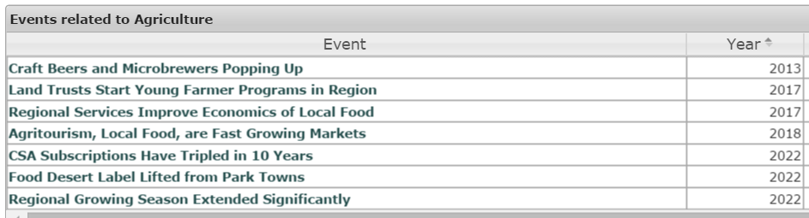

Arts and Culture
Heritage tourism appears to be growing all over the Park. From Great Camp Sagamore near Old Forge, to the Adirondack Museum, to the exciting renewal of Fort Ticonderoga on Lake Champlain, there are substantial investments happening across the Park. AARCH (Adirondack Architectural Heritage) tours are often oversubscribed. Great work has been done on driving ‘trails’ like the Lakes-to-Locks passage. A number of other driving trails are in the works: the First Wilderness heritage corridor and an arts trail, are just getting launched. John Brown Lives! is bringing the region’s surprising black history to life. Many of these efforts are new options for people with young children or older visitors less inclined to hike the high peaks.
An arts and heritage summit was held by ADK Action in September of 2015. That meeting has already resulting in an arts calendar for the whole Park, something people have talked about for years. A traveling Shakespeare Company and Adk Lakes Summer Theater Festival are now touring groups that move around the Park instead of being moored in a bricks-and-mortar building and requiring people to come to it.
Thanks to a major funding campaign led by ANCA, all the movie theaters in the Park managed to make the conversion to digital projection so they are now better than ever.
While the arts is not a major jobs sector yet, like it is in the Berkshires for example, it is growing thanks mostly to NYS grant funding. Lake George in particular is building up a significant music festival held each summer. Two feasibility studies for new theaters are underway, one in Schroon Lake (Seagle) and the other in Saranac Lake (Pendragon). Writing programs, performing arts venues, an art trail all have been funded. Westport is has been considering the idea of turning into an ADK Art town with Amtrak access, an idea that has real potential. There is even a Star Trek fan studio operating in Ticonderoga.
One event used in the workshops proposed the idea of an international conference about the spiritual value of wilderness, which hasn’t happened, but people are talking about it. Recently, a variety of faith groups have met to talk about how the region might help with the refugee crisis. The large number of people attending and the breadth of interest from faith groups may evolve into something more. The meeting itself was unprecedented.
The arts and culture event list follows. These are the events we used in the workshops in 2011 and 2012. Go here, then click on the event titles for lists of news and developments about each event, with links to the source information.
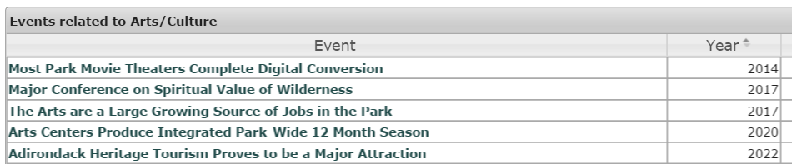

Climate Change
Progress on climate change issues is a mixed bag. More frequent extreme weather incidents will occur – that is the most certain thing one can say about it. Climate change is coming, but what exactly this will mean for the region remains unclear. This 2015-16 El Nino winter, a tourism disaster, is a preview of what is coming but it follows two brutally cold winters. The Nature Conservancy expects the Adirondacks will become a refuge for many species moving slowly north, so biodiversity in the region will rise.
State government is very active on climate issues. New state bridges, for example, must take climate forecasts into design consideration. The Regional Greenhouse Gas Initiative (RGGI, our 11 state carbon cap-and-trade system) is doing very well. Carbon emissions from power plants in NYS have declined 40% since 2005. Dams damaged in storms are being removed instead of repaired at Marcy Dam, in Moriah and Willsboro. A 125 location weather sensor network is under construction across the State; the Arietta Airport and 5 others in the Park have APA approval.
There have been occasional studies documenting, for example, bird species shifting uphill on Whiteface, testing for cold water fish refuges, tracking insects and so on. Some boreal species seem to be declining. Unusual butterflies have appeared. Ice in/out records are showing shortened winters. Loggers have noticed the winter logging season is shorter, farmers have noticed the growing season is getting longer. On the other hand, the past two frigid winters saw appearances by arctic snowy owls and ptarmigan. Blue-Green algae blooms are more frequent in warmer water in Lake Champlain, but dairy farming in Vermont is the main culprit.
While Florida is becoming aware of its fate in the face of sea level rise, and the southwest is getting the idea with its drought issues, there certainly is no sign yet of climate refugees moving into our region. Population in the southern US is still growing while it shrinks in the north.
Buyouts of flood damaged homes in Jay and Keene have been completed and the homes removed. Rebuilding of most Ausable Valley bridges is ongoing, all engineered for larger stream flows. Several large culvert demonstration projects have been built with large open bottom designs that allow fish and wildlife passage in a natural bottom stream bed. This design is intended to allow fish seeking cooler waters to move upstream, but these are expensive and no path to regular funding for them has developed.
Two very cold winters were followed by a record El Niño for 2015/6 which brought the warmest fall on record. A World Cup skiing event was moved to Utah. An Indian Lake ice fishing event was cancelled. ORDA continues major work to save energy and move to renewable energy; all its venues use more energy in warm winters. Winter visitors account for 1/3 of the tourism economy. It is more sensitive to weather than summer tourism. Events and activity related to snowmobiling, ice fishing and cross country skiing are hurt the most. The 2015/16 winter is shaping up to be a financial washout.
Adirondack youth is on the world’s map for responding to climate change. The Wild Center’s annual Youth Climate Summit is being copied across the globe, bringing White House and COP21(Paris) honors to the youth organizers. A PBS documentary was produced around their work.
The climate change event list follows. These are the events we used in the workshops in 2011 and 2012. Go here, click on the event titles for lists of news and developments about each event, with links to the source information. In 2015, a CGA Forum working group produced this outlook for an Adirondack response to climate change.
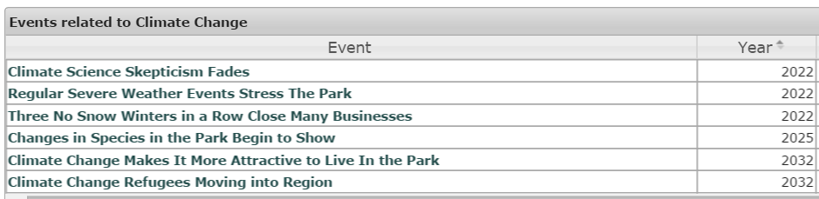

Community
The Adirondack Common Ground Alliance continues to meet annually. It is highly regarded in Albany, producing the Blueprint for the Blue Line legislative agenda, and it has been given various awards. This project, ADK Futures, was an effort of the Common Ground Alliance. The power of it arises from the ongoing open inclusiveness of its annual forum which continues to draw people of all ages and interests. There is nothing else like it in the region.
There have been Park-wide summit meetings (think of these a region-building) for four areas:
Tourism, a conference organized by ROOST, with another set for March 2016
Arts and Culture, a conference organized by ADK Action
Non-Profits, a conference organized by the Adirondack Foundation
Diversity, a symposium organized by the new Adirondack Diversity Advisory Council
Each of these has resulted in stronger regional linkages, but they will take time to turn into regional projects and programs. Tourism has seen the most notable shift to a regional orientation so far (more about this later).
Citizen organized efforts include Long Lake’s ‘tidy town’ initiative. Winter 46 climbs to benefit high peaks stewardship have been successful. Another citizen group rescues old lean-tos. ARISE has had a big impact on Tupper Lake, running the ski mountain. Citizen science projects include winter wildlife tracking, a cougar watch program, a wetlands phenology project, and invasive species identification.
There was an effort to build an online volunteer matching site for the region (actually there were 10, in different NYS regions) but it appears to have failed. There are other, more local, volunteering guides that are easy to find.
After Irene and other storms, the State has set up a network of Volunteer Organizations Active in Disasters (VOAD) to be activated when needed. VOAD is an attempt to improve the organization of volunteer efforts during disaster recovery efforts.
Affordable housing remains a complicated issue. Habitat for Humanity is active. Grants for housing have been awarded. There are small successful projects here and there. But a 6 home project in one town has struggled unsuccessfully for years to attract people interested in living there. So progress is mixed.
Two villages have created classic Community Development Organizations: Lake Placid and Ticonderoga. They are making a difference in both places.
Two areas, Newcomb and Cranberry Lake, have been beneficiaries of estates worth millions left by passing boomers. These surprise bequests were to the Adirondack Foundation, which handles the funds, and a local town group to make decisions about distributions. As the baby boomer cohort passes, there will likely be more of these sorts of bequests.
The community event list follows. These are the events we used in the workshops in 2011 and 2012. Go here, click on the event titles for lists of news and developments about each event, with links to the source information.
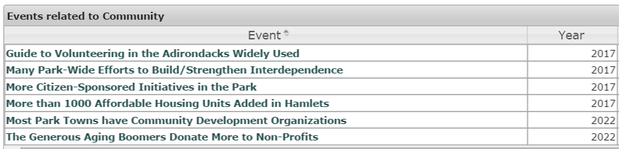
Demographics
Total population has remained largely flat and trending older, typical of northern rural areas. Compared to the rest of New York State, parenting age groups are a significantly lower portion of the population in the Adirondack Park. Some boomers move here in early retirement, but it is the lack of working age parents that is most notable. The region is showing up in the media occasionally as a great place to retire to. It is moving toward the age profile of Florida; we will reach a median age of 50 fairly soon.
Broadband is showing it can attract people to Keene, site of the first broadband buildout in the region. Prior to broadband, entering kindergarten classes had only 5 children and are now more than triple that. But it is a long slow process, and it is about more than just broadband. Cell service, social life, nice shops, pre-school and child care services, health care, a great school, and so on are all needed to attract people. Broadband is a basic requirement, but it takes more than that to rebuild a school age population based on telework. Adirondack Teleworks has been organized in Indian Lake to expand telework jobs in the Park.
Diversity is now a much higher profile issue. Schools bring in foreign students. Camps bring in inner city kids. An Adirondack Diversity Advisory Council has formed. Faith groups are gathering to see if the region can support refugees. We have economic diversity, but we are still nearly totally white in a State that will soon be minority white. We are just beginning to notice non-white visitors in the region and we have yet to embrace them. Not long ago, there was no discussion of this, but now lots of people talk about it. There are people who push back on this as evidenced by racial incidents at SUNY Canton and comments in the Adirondack Almanac when articles on the topic appear.
NYS mirrors the national trends of a shrinking rural and increasingly urban/suburban population. Towns that lost traditional large employers like Port Henry, Newcomb, and Clifton-Fine have seen their populations collapse. So far, nothing has turned around these areas but most are betting on tourism and recreation. Trends in prison populations suggest more closures are coming. The learning is that single large employers bring with them the risk that they close. In little towns, adding a few employees to an increasing number of small businesses is a more stable path forward.
There are bright spots. One bright spot is in the Champlain Valley where parent-age people are arriving to be part of the growing local food/brewing/farming scene. Spend any time there and the impact of youth is very noticeable. Another bright spot is the arrival of Chinese billionaire investor Jack Ma who purchased a 28,000 acre estate called Brandon Park near Paul Smiths. He is a high profile conservationist, on the global board of The Nature Conservancy, and may attract other wealthy Chinese to the region as they look for ways to move capital out of China.
Tri-Lakes and Keene school populations have been flat or ticked up a bit recently, but other districts continue to see steady decline in enrollment. The beauty of small numbers is that it doesn’t take much to make a notable improvement.
Broadly speaking, the Park has serious population decline and aging problems. It remains possible that a couple of towns will shrink to the vanishing point, other towns will be more stable or even grow. The Lake Champlain towns, for example, with Amtrak service and expansion of the Plattsburgh Airport, could see a renaissance of sorts based on agriculture and arts if they actively work on it, seeking newcomers, embracing and supporting them.
The demographics event list follows. These are the events we used in the workshops in 2011 and 2012. Go here, then click on the event titles for lists of news and developments about each event, with links to the source information.
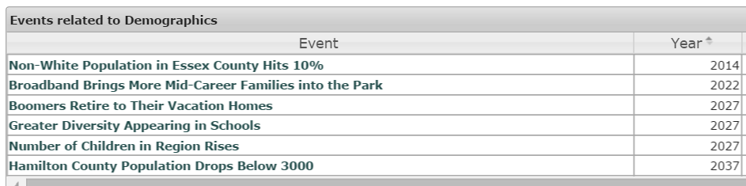

Education
At the public school level, several districts have boosted student numbers and increased diversity by adding foreign students (most notably at Newcomb) and by attracting tuition paying students from nearby districts (most notably Keene). Five high schools in the Park rank in the top 20 in the State based on standardized testing and graduation rates. The best school districts are seeing flat enrollment but, more broadly, school age population in the Park has continued to decline as working age parents leave.
Two small school districts, Raquette Lake and Piseco, have ceased operations and pay tuition to send their students to nearby schools. The Lake Pleasant School district (Speculator) has never had a high school; it gives students a choice of two nearby high schools to attend. The concept of a non-operating school district might become more common in the Park because it avoids the complexities of a real merger.
Shared services among schools are still weak. Occasionally special teachers are shared. Westport and Elizabethtown share a superintendent. Merger sports are growing. Keene and Schroon Lake share a food services manager. There are ongoing studies of more shared services and even mergers but the process is slow and difficult. Mergers are complicated by substantial differences in State aid to schools often making voter approval of mergers impossible. One proposed merger that did make it to voters was rejected.
One event from the workshops posited the establishment of more guide schools. It turns out there are already guide school programs at Adk Community College, North Country Community College, Paul Smith’s College and the largest program in the region at SUNY Plattsburgh. Organizations like The Wild Center and Adk Mountain Club offer large schedules of ecology oriented outings for all types of people.
A couple of colleges including SUNY Plattsburgh, SUNY Adirondack, and Clarkson University all offer entrepreneurial programs. Clarkson is part of the State’s Innovation Hot Spot system. All of these programs are linked to Point Positive, the region’s new angel investing group.
Paul Smiths College has excellent job-track programs in fisheries, wildlife science and environmental science. But the college is financially weak, like many other small rural schools. It nearly collapsed and had to turn away a major gift when a proposed name change was rejected by a judge.
Overall, the public education conversation during this period was about the common core, testing and teacher evaluation. These issues are the same all over the State, not special to the Park. The State is now lightening up on testing and teacher evaluation.
The event list for public schools and area colleges follows. These are the hypothetical events we used in the workshops in 2011 and 2012. Go here, and then click on the event titles for lists of news developments about each one and links to the source information.
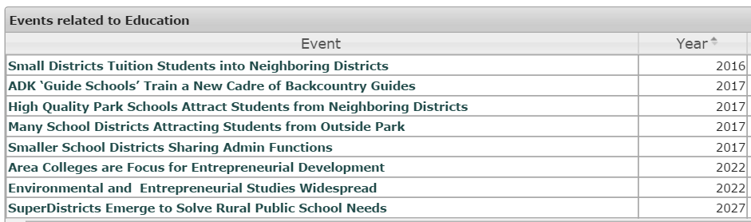
Energy
Concerns about carbon emissions dominate the energy discussion. Several projects developed baseline data for the region at the county level. It turns out that power generation in the North Country Regional Economic Development (NCREDC) region (which includes much of the Park, up to the Canadian Border), is dominated by hydro dams and wind farms in the St Lawrence Valley. The region only consumes about 1/3 of the power it produces. The needed wind resource for commercial development is in farm land north and south of the Park in the St Lawrence and Mohawk river valleys, not in the mountains.
A new transmission line is in the permitting process to bring wind and hydro power from the region to New England via an existing ROW. A second transmission project will bring Canadian hydro power to New York City via a DC cable buried under Lake Champlain and following the Hudson to the City. An innovative new underground pumped storage project in the old mine tunnels of Moriah is in the final stages of permitting; it would have a huge impact on the tax base of Moriah.
Solar is viable and growing. Community solar farms, on old landfills for example, have just now be made legal and are only beginning the permitting process. Municipal power is increasingly solar-based. Homeowner solar is growing. The State’s direction for solar is to shift from a subsidy model to a financing model. Also worth noting is the largest solar panel manufacturing site in the nation in under construction in Buffalo.
Natural gas has replaced fuel oil at the Ticonderoga paper mill, one of our largest CO2 emitters. The other larger emitter in the region is the Alcoa operation in Massena which is more likely to close than reduce emissions by other means. Fracking in NYS has been banned, and most of the Park has no gas lines so pipeline gas is unlikely to have much impact on the region.
The carbon math for wood fueled power plants is weak compared to the carbon math for local thermal heating from wood, which is pretty good. Wood fueled power plants use whole tree chips, while wood fueled thermal heat generally uses pellets made from pulpwood, not chips. Biomass started off big with the conversion of a coal fueled power plant in Watertown to wood but no other wood fueled power plants are planned in New York.
There has been some adoption of biomass for thermal heat in larger buildings like schools, museums, some government buildings. A home biomass heat demonstration project is getting some traction. But biomass is not booming. Oil prices have dropped so much that the price incentive to switch from oil to wood has shrunk dramatically. Like all biomass (eg ethanol) the value of it as a renewable fuel has been questioned because one still burns it and it still emits CO2.
Some ecologists have raised questions about the impact of whole tree chipping removing so much biomass from forests in the Park, but no more wood power plants are planned. Good data about past vs current harvest volumes is hard to find. Advocacy groups are worried about shorter-term harvest cycles, pondering if clear cutting is alright or not, and if harvesters are properly sorting out high value saw logs from pulpwood and whole tree chipping. On the other hand, having a market for poor quality wood is necessary to improve the quality of the remaining standing forest. A new sawmill is being planned. Some very large tracts of timber changed owners. Our two remaining pulp mills (Ticonderoga and Corinth) have complained that they are paying more for wood due to the demand for biomass heating. The APA issued only 10 permits for timber harvesting in 2015.
In the meantime, the biomass business is booming in Maine, New England and in the Southeast, becoming the replacement market for wood where pulp mills have shut down, often using the same industrial sites. Vermont, for example, heats most schools with wood. There are wood fueled power plants scattered all across new England, many of them struggling with low power prices now. The big volume market is exporting wood to the UK and Germany where it is burned for power production.
So progress on biomass is mixed even though the carbon math for local thermal heat from biomass remains pretty convincing. Collectively, we seem to have uncomfortable feelings about increasing the volume wood fueled heating in the Park, despite traditional use.
The event list energy efficiency and fossil fuel use reduction follows. These are the hypothetical events we used in the various workshops around the region in 2011 and 2012. Go here, click on the event titles for lists of news developments about each one and links to the source information.
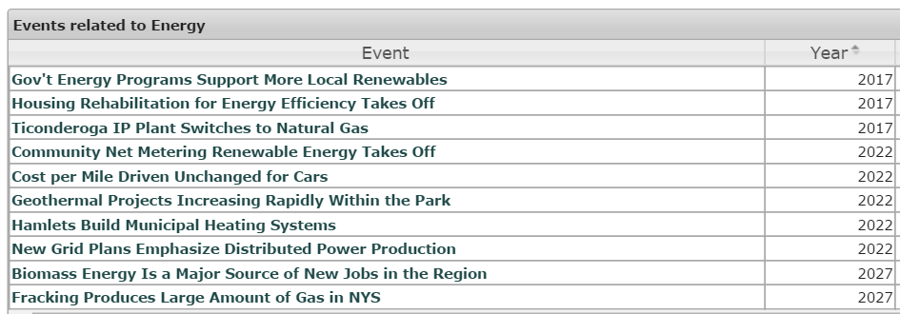

Economic Development
One big step forward has been the completion of a project called Advantage Adirondacks. It offers a well thought out set of options that a town can use for its own economic development plans. It was sponsored by AATV and the Adirondack Partnership, funded by the NYS Department of State and this project, ADK Futures, was used as the funding match required by the State. If you have heard about Art Towns and Trail Towns, for example, this project is where those ideas came from.
Global Foundries, in Malta NY, north of Saratoga, is the single largest semiconductor fab in the world now. The company also acquired IBM’s chip business including the fab in Burlington. Global Foundries make chips for smart phones among other things and continues adding capacity. It has caused a boomlet of sorts in the immediate area. Another semiconductor facility is being near Utica/Rome and it should benefit the far southwestern area of the Park. Plattsburgh’s best business is building subway cars for New York, Chicago and San Francisco which brings some employment to the northeast area of the Park. There are a number of other small new manufacturing operations outside the edges of the Park, but not much to report about inside the Blue Line.
A group of 15 people formed an angel investor group, called Point Positive, based in Saranac Lake. So far, they have funded four companies in the region. It is doing alright, but it is also proving how difficult it is to attract investors and how it is hard to find business opportunities inside the Blue Line. It needs more members/investors to be sustainable.
Broadband projects continue to make strides all over the Park. Progress is slower than people still without service would like. However, given the scope of the problem, the time involved in permitting and grant writing/approval, slow payments from the State for grants, and so on, decent progress is being made. Albany is determined to solve this problem across the State. In 2-3 years, all these projects will be complete.
But broadband will not differentiate our region, it will just make it the same as anywhere else. By itself, it is not a silver bullet. Telework jobs are appearing but it takes broadband, plus cell service, access to airports, and all the common amenities expected of a nice small town to attract new comers. It takes training for current residents to use it for online work. It will be a significant part of employment in the Park, but it is going to take a while to develop. Before then, it will greatly help existing small businesses in the Park.
Main street revitalization grants have come to a number of towns including Lake George, Ticonderoga, Saranac Lake, Indian Lake, Warrensburg, Port Henry and Lyons Falls. Lake George is moving the farthest with a number of grants that will, in the end, substantially re-make the village and the visitor experience of it. It takes several years to do the planning to get a grant, then several more to do the work and receive the funds from the State. Patience is necessary.
Most tourism topics are covered in other sections (recreation, arts and heritage). In this section we proposed ecotourism as a new, fast growth sector. There are specific things, like the success of the Wild Walk, to point to. But as a sector it still is not as visible as classic recreation like hiking and paddling. The new Essex Chain lands where pitched as having economic potential for the five towns involved, but so far public use has been limited – only 77 camping permits were issued for 216 people in the entire 2015 season, barely a blip in economic terms for five towns. On the positive side, no decline in the number of visitors to interior towns has been noticed.
Another event in this section was about clean-up of the superfund site at the old mine in Fine. Clean-up work began in 2014. Most of the site is now usable. Reconstruction of the rail line to the site is now under contract. It is 25% of all land classified for industrial use in the Park, some 3000 acres. As a very large single industrial site with rail access and water, it will likely find a new use one day. These first steps are important in attracting any new operation.
The State has changed rules and regulations to make some small businesses more attractive. This is particularly true for small brewers and distilleries. The REDC process has brought in a number of micro-grants for small businesses as well in Tupper Lake and Essex County.
Two other events have not happened so far. No town has used the EB-5 visa process to attract foreign entrepreneurs to the region, but northern Vermont has done so with great success. With the arrival of Jack Ma, our new Chinese billionaire land owner, EB-5 investors may be in our future. The idea of attracting immigrants to live in the region is only now getting any attention.
Poverty has not grown as a problem for Park. It is a real issue, for sure, but there hasn’t been a large expansion of the poverty level portion of the population.
Keep in mind economic development topics show up in other sections as well – recreation, agriculture and energy for example all have their own section in this document.
The original event list economic development follows. These are the hypothetical events we used in the workshops in 2011 and 2012. Go here, then click on the event titles for lists of news developments about each one and links to the source information.
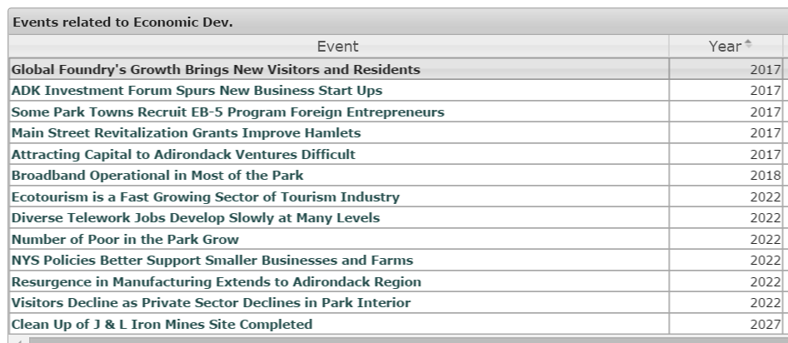
Government
In general, government plays an enormous but shrinking role in regional employment. Two prisons have closed. Continuing reductions in the State and Federal prison population are expected. Sunmount has cut its resident population by 1/3 to only 105 but so far continues to employ 900 people. 9:1 seems like an unsustainable situation. Regional DEC, APA and DOT staffing seems very thin and shows no sign of growing.
The Village of Keesville has dissolved. Port Henry has passed a dissolution vote and is in the midst of the process. Village government is the only level of local government that voters can close down by voting.
Clifton and Fine are sponsoring discussions on the merits of merging the two towns. Essex and Willsboro on Lake Champlain are increasingly aligned as well. But nothing big like merging of highway departments or towns has happened so far.
Some services are being consolidated at the county level: Essex Co runs a new emergency radio system, some 911 dispatch has been consolidated and the it is doing assessment operations for some towns. Hamilton County consolidated fuel purchases.
Perhaps the most significant is ROOST has taken on tourism marketing across Essex, Hamilton and parts of Franklin counties because it enables speaking to the tourism market with one voice. But ROOST is a cooperative effort to bring revenue into the region - all the other consolidations are about cost savings and efficiency, shrinkage of government, so while it is showing success, it is a different beast from other sorts of consolidation.
Some towns and villages are working on Comprehensive Land Use Plans including Lake Placid/North Elba, Lewis, Inlet and Saranac Lake. But many towns actually do not want the work load and responsibility for approving development projects as that work is now done by the APA at no cost to the towns. Under today’s tax cap regime, it is unlikely that many towns elected officials will move toward taking on controversial work done by the APA. It is easier and cheaper to let the APA do the work.
One set of ideas proposed in the workshops was realignment of State Agency regions like DEC and DOT to the Blue Line. It is clear now, this is never going to happen. For example, the Park is split among 3 Regional Economic Development Regions, but the current thinking is that the Park likely wins more grants than if it were a single region. So even regional leaders are split on the desirability of changing this. The APA and the Adirondack Housing Authority are likely to remain the only State agencies with a Blue Line defined geographic scope.
The State has moved strongly toward electronic online service delivery. DMV, sports licenses, the State health insurance exchange, and more are all online. This negatively impacts county workers and county revenues since licensing, for example, used to be done locally and generate county revenue. But it makes life easier for residents, reducing the time and expense of traveling to county offices.
The event list for village, town, county and state government follows. These are the hypothetical events we used in the workshops during 2011 and 2012. Go here, then click on the event titles for lists of news developments about each one and links to the source information.
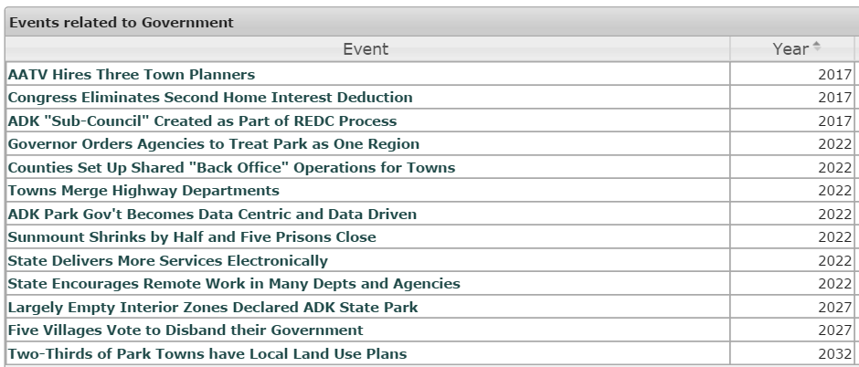
Healthcare
The big thing that has happened in health care is implementation of the Affordable Care Act. The region was well prepared for the shift because it was already years into a multi-year trial of a wellness, primary care centered, health system called Medical Home. The shift has been difficult. Hospital admissions have dropped, causing big losses, and primary care has seen investment. Warrensburg has a new 38,000 sq. ft. health center. Ausable Forks has a new health center. New clinics opened in Tupper Lake and Saranac Lake. The NYS health insurance exchange went live bringing more insurance options, better pricing and better coverage than the region has ever had before (this observation from my personal experience).
Elizabethtown Hospital joined with CVPH (Plattsburgh) and Fletcher Allen (Burlington) to form the Vermont Health Network and later the Malone hospital joined the network. Elizabethtown Hospital and Adirondack Health have embarked on major capital spending programs including a large new facility in Lake Placid that will replace the old hospital.
A new assisted living facility opened in a renovated school in Willsboro; it includes a memory care unit. The Uhlein nursing home sale in Lake Placid came with a commitment to spend $4.5 million renovating the facility, including the addition of assisted living services.
Three nursing homes have changed owners, none have closed. Their problems began with cuts to Medicaid, but the State stepped in and saved these operations from closing. Lack of home care aides has been a dire problem, especially in Hamilton County.
A fiber telemedicine network now reaches all the health centers in the Park. A law was passed that allows doctors to get paid for time doing telemedicine. So this piece of future health care is in place.
There is continued discussion of moving to paid EMT services around the Park. The first step has been taken in Willsboro/Essex where ownership of the rescue squad has been changed so it can accept insurance payments. The volunteer shortage is very real, but changing to paid staff is complicated and slow.
The event list for changes in health care follows. These are the hypothetical events we used in the workshops in 2011 and 2012. Go here to the live site, then click on the event titles for lists of news developments about each one and links to the source information.
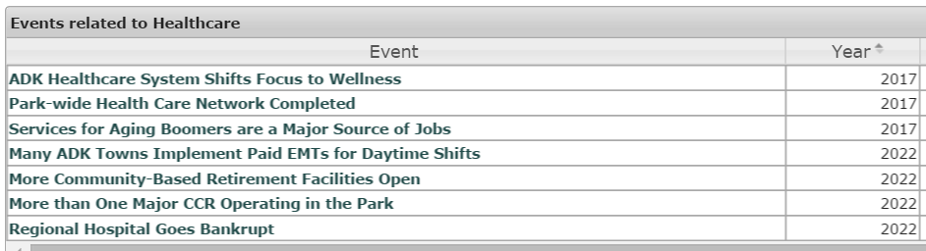
Promotion
The big change in promotion is that ROOST has stepped into the role of unifying regional tourism marketing. ROOST held a destination marketing summit that reconfigured tourism marketing. A second summit is set for March 2016. A Park-wide tourism portal is operational. The State has regularly funded promotional campaigns ranging from subway and bus ads in NY City to the governor’s Adirondack Challenges in summer and winter tourist seasons. These do have an impact, especially the NY City transit campaigns. We are beginning to see non-white visitors in the larger places like Lake Placid.
Events are a big feature of marketing the region. Fishing events, art and music festivals, winter and summer sports events, food events, community garage sales – all draw people to towns and villages of all sizes. There is no end to the creative ideas for events. New facilities help too, the most successful addition being the Wild Walk last year. New exhibits being developed at the Adirondack Museum have generated high expectations. The new outdoor performance space in Lake George is fully booked with events of many sorts aimed at different audiences.
Cell service is spreading all over the Park providing a foundation for real-time location based promotions. The APA issued 21 telecommunications permits in 2015. People use their smart phones to find a place to eat, stay, shop and so on as they travel around the region. It also supports shifting driving tour information from paper maps to cell phone apps. Lakes-to-Locks Passage is way out in front of this change. There are more in development.
The region, especially Lake Placid, gets television coverage for major sports events like Iron Man and winter sports World Cup competitions.
The State now will put icons on your driver’s license for boating, hunting and fishing licenses so you don’t have to carry all the small papers. But no other large unified ticketing program has taken hold. Where they have been tried, they only see minor success.
There has been no regional campaign to attract teleworkers, the newly retired, or aimed at keeping area college students in the region (surveys say they would stay if there were jobs). Similarly, there has yet to develop a ‘made in the Adirondacks’ brand or identity, although ANCA is working on a project concept.
The region’s UN biosphere designation (1989) remains an unused asset. It got caught up in the fake Agenda 21 controversy which was problematic enough to stop the region from using this world site designation for tourism promotion.
The event list for promotional work follows. These are the hypothetical events we used in the workshops in 2011 and 2012. Go here, click on the event titles for lists of news developments about each event and links to source information.
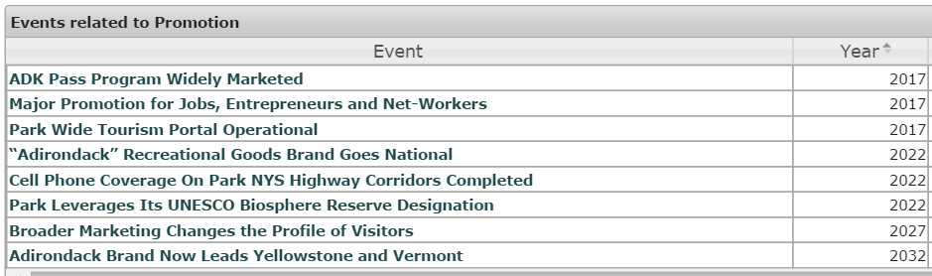

Recreation
The most impressive thing about recreation is the large number of State investments replacing and upgrading public access facilities all over the Park for all sorts of recreational activity. I list a few below, but go to the live site for a more complete list.
Reconstruction of Bulwagga Bay lakefront in Port Henry
Rebuilding lakefront Arrowhead Park in Inlet
3 new waterfront parks on the West Branch of the Ausable River
Upgrades along the 90 canoe classic race route
Renovation of 2 waterfront parks in Northville
New public docks and waterfront improvements in Lake George
New docks, parking and facilities at Second Pond, Lower Saranac Lake
New sports fields in Lake Placid and Saranac Lake
Projects for the Essex Chain lands, including horse facilities, camp sites, parking, signage
Lower Sargent Pond and Hawk Pond trout fishery restoration projects
100 new snow guns for Gore Mountain
Abanakee Dam improvements (Indian Lake), critical to Hudson River rafting
Upper Saranac Lake boat launch replacement
Repairs to locks and dams at 3 sites
2 fire tower restoration projects
Waterfront revitalization projects in Clifton-Fine and Newcomb
New public docks in Bolton Landing on Lake George
Bear Pond lime treatment project
New performance festival space in Lake George
New visitor centers in Bolton, Newcomb and in Warren County
New recreational docks on the LaChute River
Various trail improvement projects
Paradox Lake dock and campground upgrades
Added parking and new bike trails in Wilmington
Improvements to Rodgers Park in Bolton Landing
New waterfront park in Tupper Lake
Investment in Camp Colby for inner city children

It is an impressive list. Much of the actual construction is still underway, but all this work is funded.

Private investments in hotel properties include a $25 million renovation of Camp-o-the-Woods, in Speculator, a Marriot in Lake George, renovation of the Hotel Saranac, also smaller renovations in Schroon Lake, Ticonderoga, Lake George, Warrensburg. Two large renovation projects have been completed in Lake Placid. There are new projects in permitting in Schroon Lake, Speculator and Saranac Lake. The Adirondack Club and Resort project in Tupper Lake continues slowly moving ahead. The Sagamore Hotel in Bolton Landing is now open all year and the owners purchased the Lake Placid Lodge as well.

Private funding is going to more than just hotels. A high end camping business in Johnstown (Camp Orinda) has been featured in the NY Times. The old Crescent Bay marina on Lower Saranac Lake is in permitting to do a major rebuilding project. A new marina opened in Port Henry. A new wave park for paddlers is on the Sacandaga River. Oak Mountain Ski Center near Speculator has new owners. The Lake George area will see a nearby zip line open in 2016. A former ranch and golf resort in Stony Creek (Warren County) is being turned into a year-round science camp and family resort. Rolling Hills Farm in Westport is being turned into a private club and operating farm resort.

Some visitors view shopping as recreation and they will enjoy a new Marshalls in Lake Placid and an LL Bean outlet store in Lake George.

Warrensburg and the Upper Hudson area have pulled together a funded plan to highlight the “First Wilderness’, an idea born in the area. A project is underway to create a trail-and-lodging system to operate like the hut-to-hut systems in other areas.

A public/private effort has produced a recreation plan for the whole Park, approved by various groups and now in implementation. A network of trails that connect hamlets is being built for snowmobiles, enhancing the riding experience and the winter economy of small isolated hamlets.

Surveys of visitors often mention hiking as a top activity, but the surveys also reveal most people want a half-day hike. That has spurred new short trail systems to grow and be better promoted. Henry’s Woods trails near Lake Placid (the Uhlein property) is increasingly used and has added more trails. The CATS system on Lake Champlain has a loyal following. Short trail systems in Saranac Lake, Chester and Lake George are being successfully marketed. These systems provide hiking options well outside of the High Peaks, a long sought goal. Back country use is also up, a backcountry powder skiing association has been formed and 46er registrations have exploded compared to prior times.

Cycling is growing is a couple of forms. Iron Man has brought bike racing to the Lake Placid region. The Wildlife Conservation Society is running an annual two-week bike/camping trip around the region. Wilmington has focused on trails specifically aimed at trail biking, intending to be the trail biking center for the Park. More family-style, safe, off-road biking is now permitted on the former logging roads of the new Essex Chain lands.

For all the things that have happened, some things are clearly not going to happen. No casinos will open in the Park, or even in Saratoga. There has been no suggestion of increasing user fees for the Park beyond those in place at some State campgrounds. Nor has there been any discussion of a (free) permit system set up to deal with crowds at heavily used areas in high season. Only popular camping areas have any sort of reservation system. The response to heavy usage of popular trails has often been to upgrade the trail; more trails need hardening now.
It isn’t clear that guide businesses have expanded much, or at all, as a visitor offering.
The conversion of the Lake Placid-Old Forge railroad to a rail-trail, and ending the tourist train between Lake Placid and Saranac Lake has become hugely contentious. The State’s proposal to make it a trail from Lake Placid to Tupper Lake, then revive rail service from Tupper Lake to Old Forge does appear to be how this will be decided sometime in 2016. Stay tuned.
The rise of more diverse recreation options, like varieties of biking, back country skiing and snowmobiles has been met with some concerns from advocacy groups that the Forest Preserve will see more negative impacts. Indeed, any hiker can tell you that even overuse by too many people walking creates visible damage to trails. Others point out that recreation is the root of continuing support for the Forest Preserve and the local town economies. Some suggest the solution is a larger budget for maintenance. This is a classic Adirondack conflict, likely to continue for some time to come.
The event list for recreation follows. These are the hypothetical events used in the workshops in 2011 and 2012. Go here, then click on the event titles for lists of news about each event and links to source information.
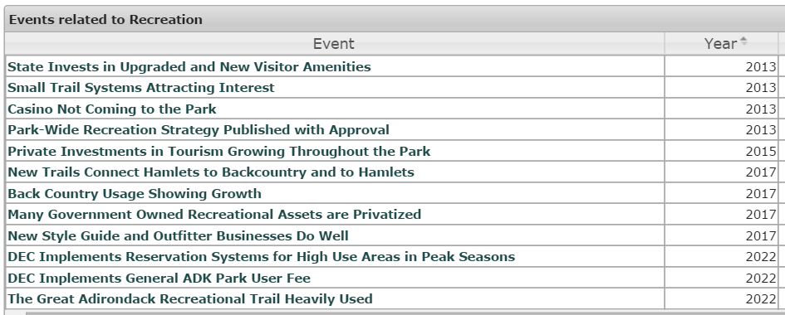

Regulation
In 2013 two amendments to Article 14 passed. One, called Township 40, resolved 100-year-old land title disputes in the Raquette Lake area. The change allowed most owners (largely seasonal camps) a path to purchase clear title from the State. It was not controversial, instead it was more like finally getting to the resolution of a long running saga. The other amendment was to swap a small parcel of never visited Forest Preserve adjacent to an existing mine for some 1500 acres to be added to the Forest Preserve elsewhere. This split the region’s advocacy groups with the two larger ones, Adk Council and Adk Mountain Club, in favor and the two smaller groups, Protect! and ADK Wild, against it. There was heated controversy about it. Even after it was approved by voters, there were a couple of legal actions to stop it, but they all failed.
In 2015, DEC embarked on an experiment with ‘complex planning’, also called ‘large landscape planning’ in the southern area of the Park, labelled the Great South Woods. The work underway is being done by SUNY ESF. It is a potential response to the awkwardness of the UMP planning process, which covers Forest Preserve land only, tract by tract, without much regard to the surrounding area. Collaborative approaches to large landscape planning are a common theme in conservation nationwide.
Agreement that the 1970s State Land Master Plan (SLMP) needs updating has led to the APA managing the process. As of January 2016, proposed changes are out for review via public hearings and a comment system. The points of controversy are what one would normally expect. Changing the SLMP requires only the Governor’s signature.
TDRs (Transferrable Development Rights) continue to be discussed. The goal is to move some development rights from the 44 acre/home back country to the higher density zones closer to hamlets. The only development so far is that the most of the advocacy groups now think this is a worthy route to a worthy goal. Two bills for TDRs have been proposed but neither made it to a vote in the legislature.
The Common Ground Alliance set up a working group that did the basic work trying to scope out an Article 14 amendment that would (1) allow buried utility pipes and cables in road ROWs in Forest Preserve (which was common and legal until 1996) and (2) move forward on existing SLMP language from the 1970s recommending a small community projects land bank be set up. A version of this work attained first passage in the NYS legislature in June 2016.
Lots of the other events in the regulation category have not developed. While the APA did hire someone into their economic development job slot, it is not the primary economic development agency for the region – that role is split among three REDCs that each have portions of the Park. One stop permitting has seen some work but no substantial change. Cumulative environmental impact studies are not being funded and there is little prospect for any funding despite the need. There is no increase in budget coming for enforcement of APA and DEC regulations, but nor is there rampant disregard of APA rules like homes being built without permits or illegal dumping. The APA is generally respected and its regulations are typically heeded.
The notion of developing a revised private land use plan for the APA is not a topic of discussion, despite agreement on the need, but small map amendments are fairly routine. Conflicts over subdivisions and private land use are centered on detailed legal definitions of terms in the law. Where some see a shift in APA standards in recent permits, others see proper application of the law. With nearly 20+ years left to go with this vision, any significantly change to the private land use regime is probably beyond the careers of current participants.
The event list for regulation follows. These are the hypothetical events we used in the workshops in 2011 and 2012. Go here, then click on the event titles for lists of news developments about each event and links to source information.
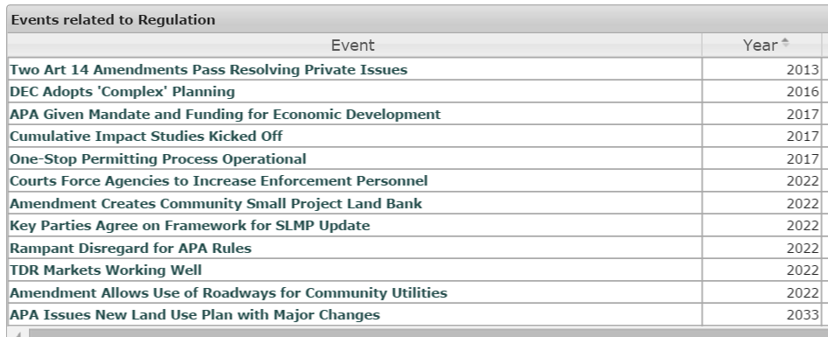
The Forest
The State is only one purchase away from completing the Finch land acquisitions, multiple tracts totaling some 69,000 acres, the largest addition of land to the Forest Preserve in 100 years. One other tract, Follensby Pond, is owned The Nature Conservancy and is likely to be acquired by the State. Many have said these are the last large acreage deals, but additions of smaller tracts are expected to continue.
There has been some effort, but so far no notable success toward stopping insects like Woolly Adelgid (now showing up near Albany) emerald ash borer (now in Quebec/Ontario) or the southern pine beetle (now on Long Island). Indeed, additional problematic insects are showing up. Insect killed forest landscapes do appear to be in our future. It is not clear how DEC will respond to infestations in the Forest Preserve. DEC has been successfully controlled feral swine, which were a growing population in the apple orchard area of Peru in the northeast corner of the Park.
The rest of the events in the category saw no major change. Forest Preserve valuation methods are not changing. Carbon sequestration payments to landowners have not developed. The idea of forest management aimed at helping it deal with climate change is not a topic of discussion, although in the Southeastern US such work is well underway in industrial forests. The Elk Lake Lodge property in North Hudson is the only big new forest easement in recent news.
The CGA Amendment Working Group explored the idea of finding a mechanism to consolidate the Forest Preserve, disposing of small randomly located parcels and using proceeds to buy land adjacent to existing large tracts of Forest Preserve. It may be possible to organize such a consolidation in the context of a planning for a large landscape complex where specific tracts of land can be identified and an amendment proposed, but the idea of putting a different mechanism in place to handle such changes does not have support to move ahead.
The event list related to the forest follows. These are the hypothetical events we used in the workshops in 2011 and 2012. Go here, then click on the event titles for lists of news items about each event and links to source information.
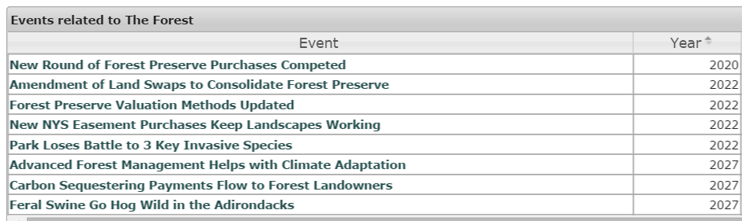

The Waters
Water quality research in the Park is showing exciting steps forward. The IBM sponsored ‘smart lake’ project is fully instrumenting Lake George with real time sensors, a first in the world. Lake George waterfront is the site of a new porous pavement experiment and work on innovative septic systems. Clarkson University has done work on property value impacts of pollution. Smart phone apps are used for identifying and mapping invasives. A wetlands citizen science project was funded by the EPA with $350,000. The Nature Conservancy has done work in Lake Placid and Follensby Pond regarding cold water trout refuges which will be increasingly important. Years of work on acid rain are paying off now as impacts lessen and fish return. There is a strong focus on road salt issues and alternative solutions are being tested. An old dam in Willsboro has been removed and should allow fish to move up to Boquet River from Lake Champlain. So research with respect to water quality is doing very well in the region, and taking steps to better organize.
Perhaps most impressive is the scope and breath of attention to invasives in lakes. The response has been creation of a region-wide boat washing system. This has brought unprecedented levels of cooperation between local government and environmental advocates. This is fertile ground for trust building that can grow into other joint civic projects. The State, lake owner associations, local governments and Paul Smiths Watershed Institute funded and organized the work. The boat washing system needs improvement, of course. Still, this powerful result of aligned action by all parties demonstrated our ability to work together and the strength of aligned action vs independent action. Road salt is shaping up to be the next area of cooperative action.
Existing water treatment systems need a lot of expensive work done to maintain, or replace, them. A fair amount of work has been done on existing systems Park and several are now the subject of State funded engineering studies to determine the scope of future work needed. Grants and loans can be expected to follow. Inlet built a new sewer system and so did Essex (on Lake Champlain). Lake George won grant funding to inspect every septic system within 500 feet of the lake and 100 feet of some streams. So broad progress is being made, but the scope and cost of the work ahead remains daunting. Some large towns are still without any sewer system – for example, Elizabethtown, a country seat with a hospital, nursing home, large school, county buildings and so on operates entirely on septic systems. For information on the projects in various towns, look at the evidence list here.
Equally important is the growing recognition that storm water projects also have a very large impact in water quality. Lake Flower will see a $10m clean-up of toxic pollutants deposited long ago in Pontiac Bay.
A variety of water quality regulations are in place and enforced. Lake George, for example, has banned use of fertilizer within 50 feet of the lake. The Sagamore Hotel in Bolton Landing was fined for a sewage spill into Lake George. Regulations required a new water system in Ticonderoga. Tupper Lake, Saranac Lake and Dannemora need new water supplies as well.
Water quality is one theme that everyone agrees upon and is working toward improving. The positive impact of water quality work is more significant than just the water improvements – it demonstrates that aligned intentions on an issue brings along State funding, attention, and an ability to have an impact on a large scale.
The event list for the waters follows. These are the hypothetical events used in the workshops in 2011 and 2012. Go here, then click on the event titles for lists of news developments about each event and links to source information.
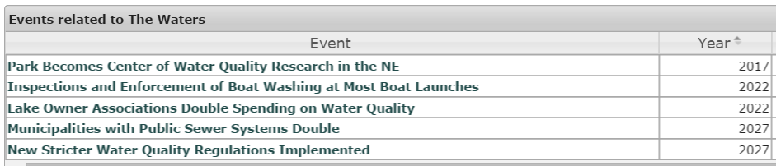

Transportation
The expansion of the Plattsburgh airport from 3 gates to 9, due to be completed in 2016, includes space for international customs. Flights to Paris, aimed at the Montreal market, are being worked on, along with more flights to southern US vacation destinations. It isn’t clear what other US cities might get service from Plattsburgh. The airport’s big success is discounted service for Montreal residents - they are only an hour away. But clearly the project also benefits the northeastern Adirondacks. Right now the strong dollar is depressing Canadian usage of the airport, but this happens from time to time and is not a permanent condition.
All other area airports continue to receive grants for improvements, but mostly for private aircraft. Watertown has added flights to Chicago, which helps a bit for northwestern areas of the Park.
Amtrak continues to run the New York – Montreal route. That track has seen significant upgrades for its entire length due to the need to safely move oil trains through the region. More importantly, a new second track allows north-south trains a path around the large freight classification yard in Balston Spa, which was a frequent source of delays in the past. The other large delay was at the border, and a new agreement will process people crossing the border before they board the train. At one time, high speed rail was studied, but the research concluded that incremental improvements were a better choice and that is what has been worked on. Amtrak runs creative co-marketing programs with Ft Ticonderoga (2 for 1 tickets) and Lake Placid (offering connecting van service from Westport to Lake Placid). Continued track improvements are expected and needed. The Champlain Valley would do well to embrace and support Amtrak. Other areas of the Park dream of having that kind of access.
Two of the three tourist trains have had financial difficulties. The run from Lake Placid to Saranac Lake now appears likely to end service, being replaced with a rail trail from LP to Tupper Lake where rail service will begin again running to Old Forge and Utica. The Saratoga-North Creek railroad began with a lot promise and even ran a ski train in winter to Gore Mountain (now stopped). It failed to develop any freight business hauling rock from Tahawus, for example. But they are not giving up yet – they are adding luxury dining and lounge cars and offering 94 dinner, brunch, and lunch train trips with locally sourced food and beverages. Stay tuned for new developments.
Bus service is the remaining option to develop. There have been press releases about running non-stop busses from Grand Central Station to Lake Placid for weekend skiers, for example, but nothing has developed. Current bus service to the region is apparently most heavily used by NYC families visiting prisoners in the region. County operated bus services are lightly used. There remains room for a research project on bus service throughout the region. No one has mapped fully mapped out existing bus service. This is viewed as an important issue for millennials who increasingly do not own cars and will need other means to reach the Park from the New York City.
DOT engineering, and some towns, are testing different winter road salt regimes and replacement chemicals. Culvert replacement projects have included a few with innovative open bottom designs to create a steam bottom passage for fish and wildlife. There have been two porous pavement experiments. The big engineering projects are bridge replacements – after years of construction, almost every State, county and town bridge in the Ausable River watershed will have been replaced since tropical storm Irene in 2011. Most of the replaced bridges date from the 1930s.
2037
Highway branding, in the form of driving tours, is seeing considerable energy. They are referred to as ‘trails’. There are a couple of heritage/history trails, several food trails, an Adirondack Coast trail along Lake Champlain. An arts trail is just being launched, and a cuisine trail (farms, restaurants, wineries, breweries, cheese makers, etc) is beginning to be organized. The old version of paper map ‘byways’ has given way to creating smart phone apps to guide people to interesting locations, food, lodging, et. A similar idea, but for waterways, called ‘blue trails’, is also getting some attention. The road up Whiteface has been rebuilt.
The newest green energy concept in the region is growing interest in electric cars, and, someday, self-driving vehicles. Success of these two technologies would change a lot of our region’s transportation and energy picture. Public charging stations are beginning to appear, now in 14 locations scattered around the Park.
The event list for transportation follows. These are the hypothetical events used in the workshops in 2011 and 2012. Go here, then click on the event titles for lists of news developments about each event and links to source information.
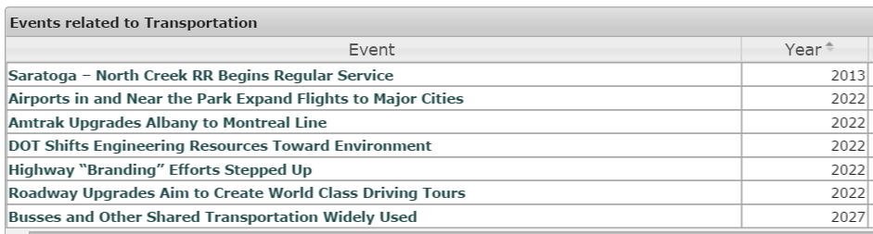

The Vision Chart
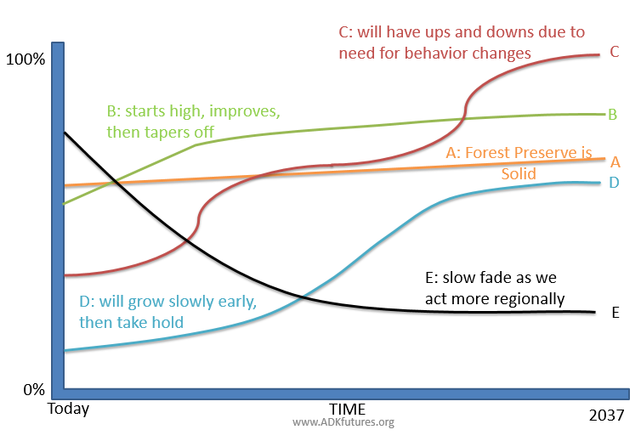

In 2012 the ADK Futures Project produced this chart to illustrate the expected rise and fall of the different scenarios over time. Today, in 2016, this chart remains a pretty good representation of what we are actually getting. But it we have a long time to go yet, until 2037.
We have done the most work on sustainable, diverse tourism (B) with lots of State and private investment. There are investments all over the Park. Lake George is being substantially remade, for example, while fully understanding the lake as what draws people to the area. Lake Placid is doing well. More importantly Schroon Lake, Speculator, Saranac Lake and even Newcomb are seeing a levels of attention and investment not seen in a long time. Recreational tourism investments were expected to be an early development, tapering off in later years.
There is also lots of progress on the sustainable life (C) scenario. The biomass energy piece of the scenario has been less than hoped for, but other areas, like building out broadband and cell service, expanding local agriculture, solar energy, etc., are making good, if sometimes slow, progress. The energy situation has changed again, with a flood of cheap oil, which will inevitably slow down the transition to renewables but this was expected and illustrated in the wave shape of the curve for the C scenario.
We have grown the Forest Preserve by 69,000+ acres, a historic amount (A). There have been the usual conflicts about classification, but regardless, the land is now Forest Preserve. Whether or not the expected economic benefits of the Finch land acquisitions accrue to the 5 affected towns will take a few years to play out. Increasing recreation tourism brings predictable concerns about overuse and conflicting priorities of different activities. Tourism marketing centered on events, not recreation, has seen success.
Government activity is shrinking at the local level due to the tax cap (E). The role of State employment is shrinking with prison closures. But the big story is a shift to regional efforts involving multiple towns and counties, like ROOST’s tourism marketing (D). We have stepped back from the ‘every town for itself’ approach. However, it is clear that other ideas discussed in the regionalism scenario, D, like turning the Park into a county, or expecting the State to reorganize its operating regions to treat the Park as a single region - these sorts of changes are simply not going to happen. Regionalization will happen slowly, but not reorganization. Regionalization has already brought many benefits to the region and will continue to do so as all sorts of groups come to see regional solutions are a better response to many issues.
Bubble Charts Showing Scenario Progress
The following six charts are graphic representation of the events in each scenario. In general, green dots suggest positive progress and red dots are negative. The size of the bubble indicates how much it influences the particular scenario.
You can see the entire set of graphs here, and toggle through them. On the live site, you can mouse-over each dot to see what the event is. Bubbles higher up on the chart are more likely given recent news.
Below you can view each scenario and, at a glance, see we are doing best on C, the Sustainable Life, and worst, thankfully, on F, the failure scenario called Adirondack State Forest. The A, Wild Park, scenario’s most negative events are not seen as likely. The B, Usable Park, scenario has seen important events become very likely or actually happen.
Some people love these kinds of charts. Other people can’t figure them out. Think they are best viewed on the live site. The worst that can happen is they will give you a headache – if so, skip it, and thanks for reading this far.
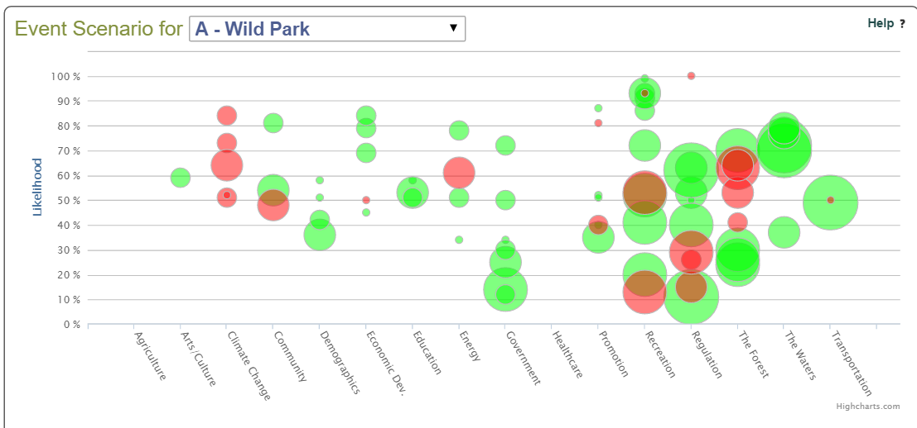
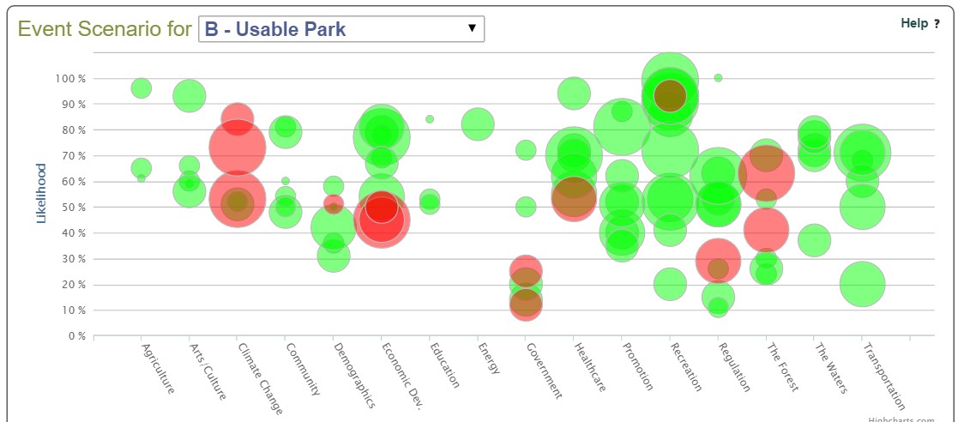
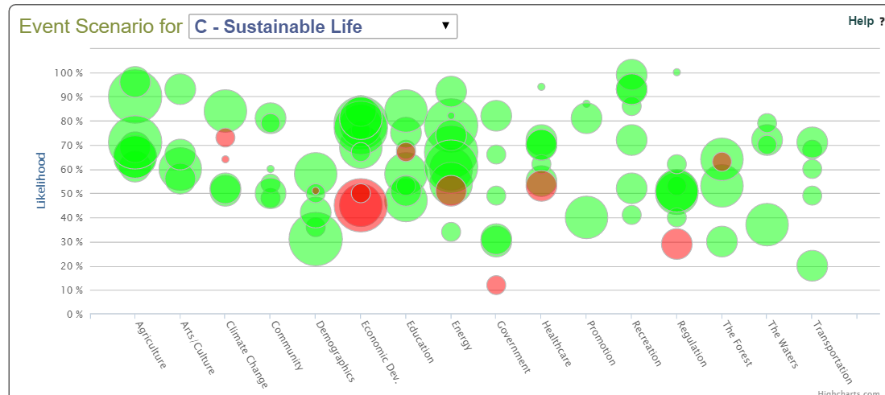
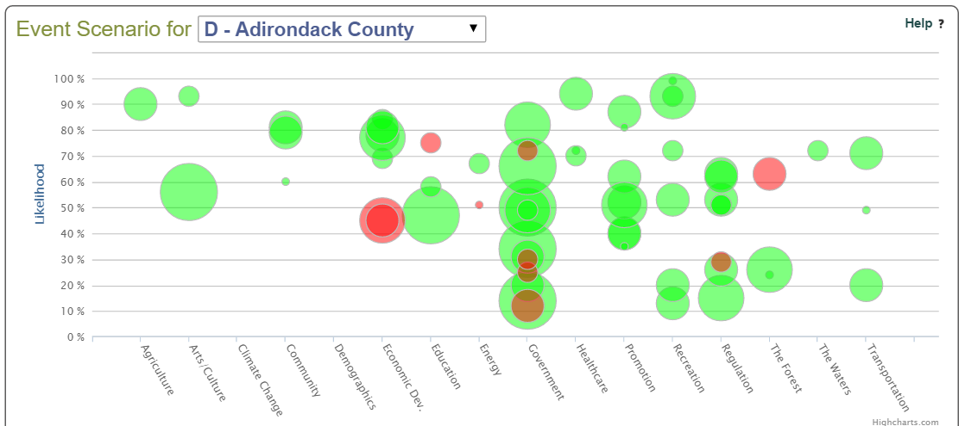
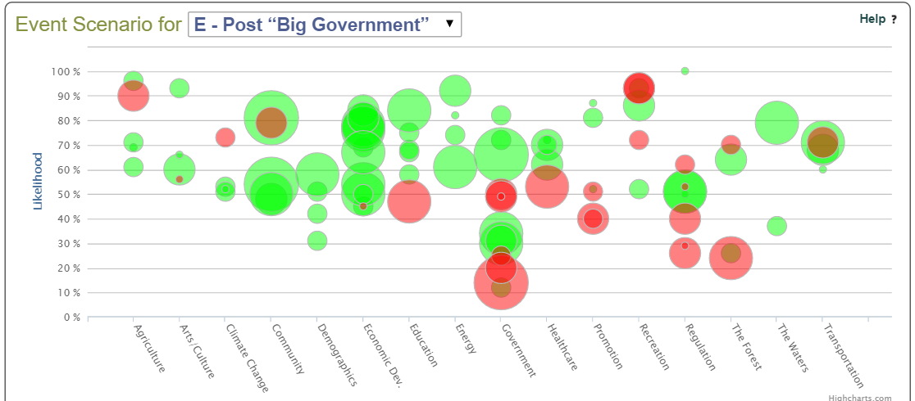
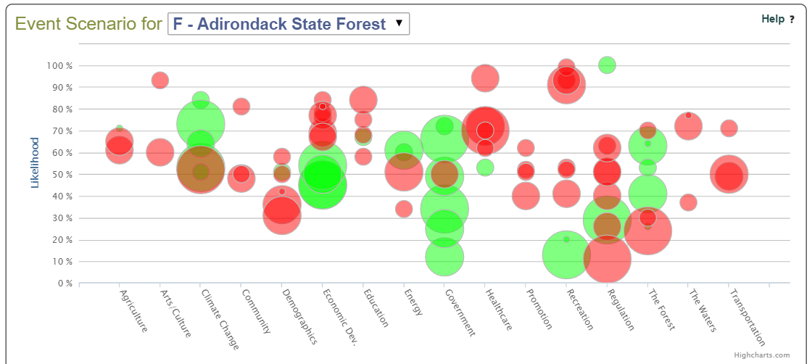

About the Author
David Mason was co-leader of the ADK Futures Project. The development of the database and the .Net website was lead by James Herman, the other co-leader of the project. The data collection has been done by David Mason and, more recently, a grad student at UVM, Carla Fox. This document was written by David Mason with the help of a number of reviewers including Carla Fox, Ross Whaley and Pete Nelson.

